Let’s See how to implement caching in Spring Boot Application?
Explain Why do we need Caching?
Explain What Exactly is Caching?
I’ll insert image – Of Client – Server Request to database without cache below
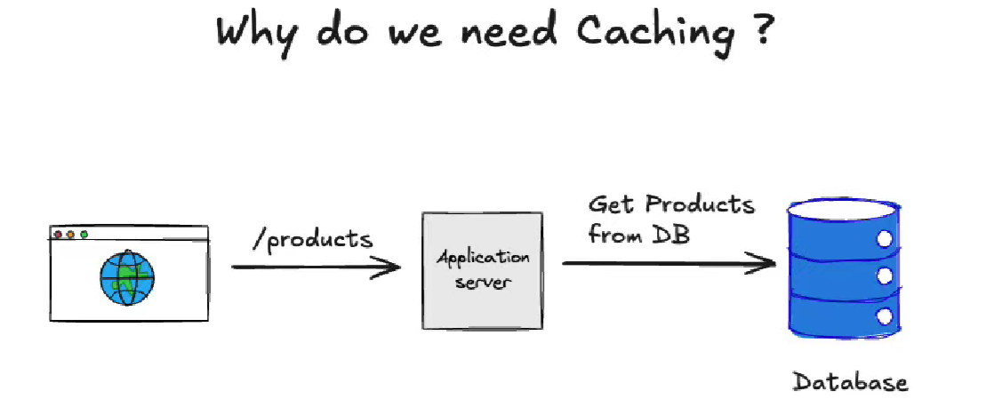
Consider an Ecommerce Application User/Customer making API request to see the products in the database from client to API request moves to Application Server and finally to database, If User Requests are more now , then that increase in number of requests can overload the application and Database and negatively affect the performance of our application.
I’ll insert image – Of Client – Server Request to database without cache with numerous requests affecting Performance below
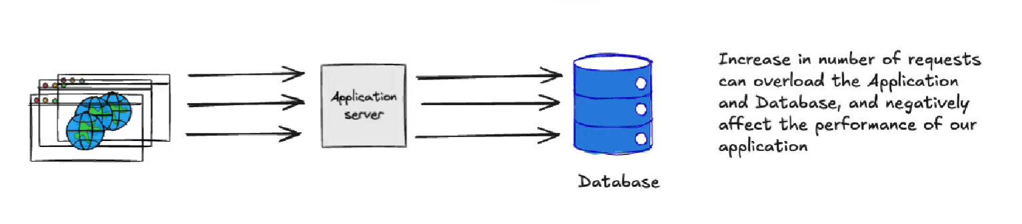
So, to avoid this performance issue caching comes into picture, Request from client to Application server instead if searching it from the database it’ll directs it request to cache.
First request goes to Database (Saves to cache as well), Sub Sequent Requests are fetched from Cache like Redis.
Explain How Request Response works efficiently with Cache like Redis.
I’ll insert image – Of Client – Server Request to database with cache below
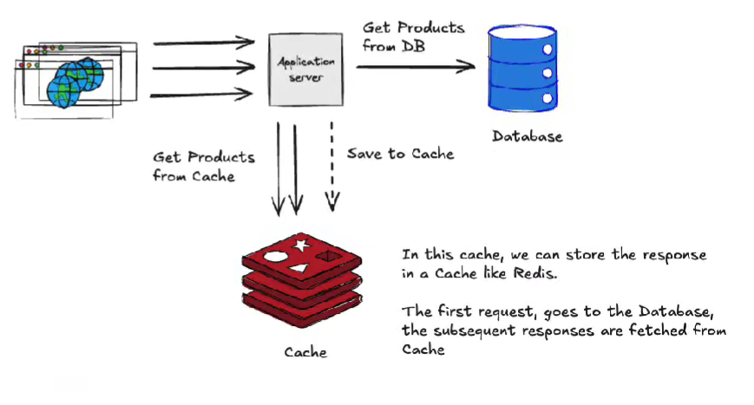
With cache how request Lookup into the cache in a request.
Explain What is redis?
Redis is Remote Dictionary Service , and an in memory database most widely used as a cache.
Can also be used as a database and a message broker.
It is designed to be a extremely fast.
It also has the ability to store the data to disk, so it can be also used as Reliable database.
I’ll insert image –What Is Redis below

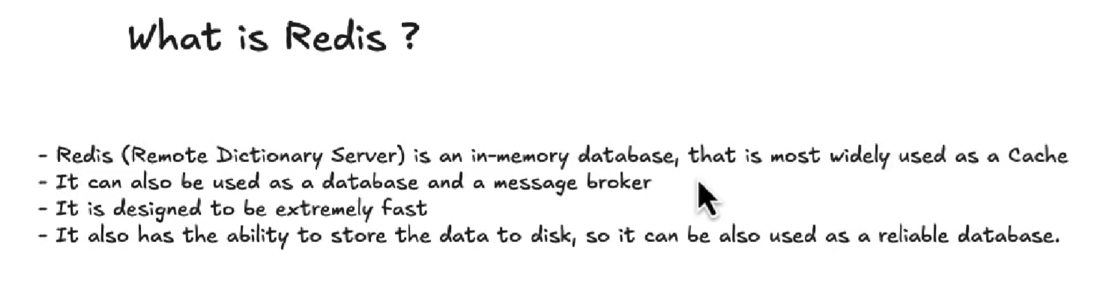
Give Introduction to redis?
Explain What is Redis? What does it do?

Include Example Explanation with API request from Client,Server,Database and Explain What is Cache,redis Cache,Cache Worker
Cache worker : It Monitors database data if any changes in database original data then cacheworker goes and populates the data into redis cache, when next time when a web server requests for any data in redis, it is updated and upto date to use.
Why do we need redis?
Why do we use Redis?
Redis is essentially a type of database,More Specifically a NoSQL Database, Definitely not similar to Other NoSQL ,SQL databases like MongoDB and PostGreSQL,MySQL.
Just Think about a JSON Object which has key value pairs of data
Redis is Like a jaint JSON – which has Key Value pairs ?
Redis is incrediably fast , is runs Inside of Working Memory – RAM , Volatile, Not like On Disk
Below I’ll insert image of Redis as JSON Object – Key Value pairs
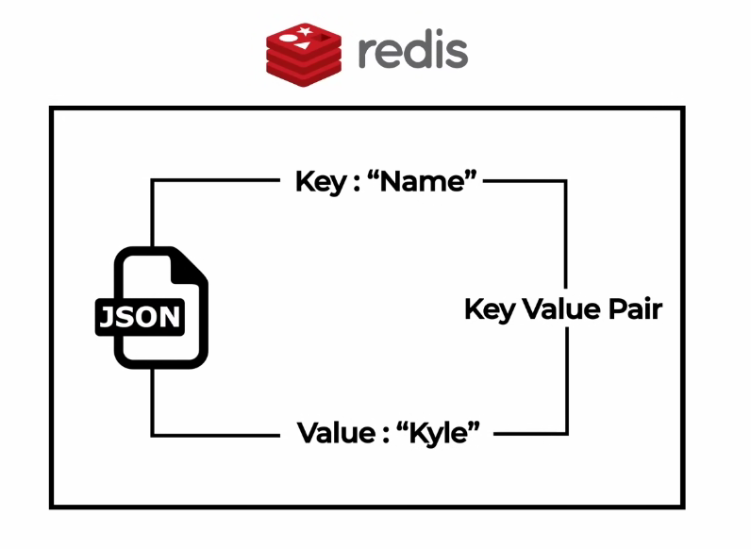

Redis is Built on top of traditional database, Redis sitting infront of that database, When shld we actually use Redis, in what cases like Data with not multiple updates but need to fetch for multiple queries not directly fecthing from database, rather bring redis cache in between these for subsequent queries data request moves to cache and request satisfied quickly.

Where does redis come into picture in Spring Boot Application Development?
Give me Architecture diagram with Redis in a Spring Boot Application?
Implement Caching in Simple SpringBoot Application?
Give What all options we have to Install Redis Install Redis Manually from Redis Website,Or we can use Docker to Install redis.

Redis Commands:
SET name kyle
GET name
- “kyle”
Everything we store in Redis typically it stores in String
SET age 26
GET age
”26”
DEL age
GET age
- (nil)
EXISTS name
- 1
KEYS *
- “name”
flushall
- OK
KEYS *
- (empty list or set)
Set name kyle
- OK
Get name
- “kyle”

ttl name (time to live)
- (integer) -1
-1 is no expiry Date

expire name 10
- (integer) 1

